# 

Supervisor:

Syed Qamar Askari

|  |  |  |  |  |  |  |  |  |  |
| --- | --- | --- | --- | --- | --- | --- | --- | --- | --- |
| Project Proposal dOCUMENT  Global Optimization using Meta-Heuristics | |  |  | | --- | --- | | Faiza Shanawar | 15140070 | | Mohsin Qamar | 15140104 | | Haider Ali | 15140101 | | Usama Imran | 15140098 | |

# 

# Document Information

|  |  |
| --- | --- |
|  |  |
| Project | Meta-Heuristics for Global Optimization |
| Document Version | 1.0 |
| Document ID | AR-01 |
| Identifier | Project Proposal Document |
| Status | Draft |
| Authors(s) | Mohsin Khan, Faiza Shanawar |
| Approver(s) | Syed Qamar Askari |
| Issue Date |  |

Table of Content

1

Document Information 2

1. Introduction: 4

1.1. Global Optimization 4

1.2. Meta Heuristics: 4

***1.3.*** ***Exploration***: 5

1.4. Exploitation: 5

2. Problem Statement: 5

3. Preliminary Literature View: 5

3.1. Some Categories of Algorithms: 5

4. Background and Justification: 6

5. Scope: 6

5.1. Our Idea: 6

5.2. Significance of our work: 7

6. Learning Outcomes: 7

7. References: 7

# Introduction:

## Global Optimization

An algorithm that deals with problems in which a best solution can be represented as a point in an n -dimensional space. The objective of global optimization is to find the globally best solution of (possibly nonlinear) models, in the (possible or known) presence of multiple local optima. Formally, global optimization seeks global solution(s) of a constrained optimization model. Nonlinear models are present in many applications, e.g., in advanced engineering design, biotechnology, data analysis, environmental management, financial planning, process control, risk management, scientific modeling, and others. Their solution often requires a global search approach.

**Optimal point (0, 0)**

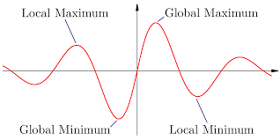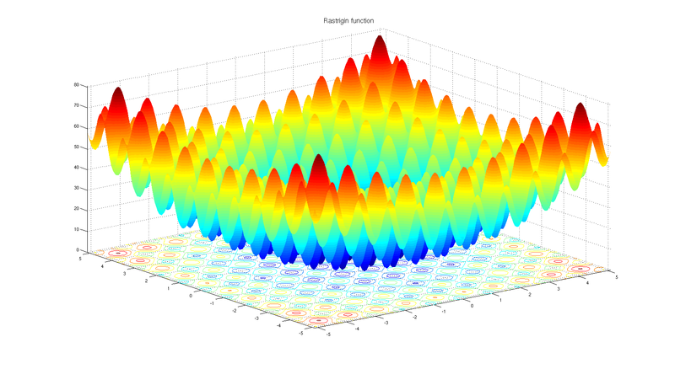

**Fig #1**: Global Optimization

**Fig #2**: optimal point for global minima

## Meta Heuristics:

A metaheuristic is a high-level problem-independent algorithmic framework that provides a set of guidelines or strategies to develop heuristic optimization algorithms. Heuristic is a Greek word which means “to solve”. It pertains to trial-and-error method of problem solving used when an exact algorithmic approach is impractical. Main characteristic of meta-heuristics is that they are problem independent. Meta-heuristics give us a way to solve complex problems that are not solvable in polynomial time (NP-Hard Problems). Although they don’t give exact solution of a particular problem, meta-heuristics provide guidelines that can give best solution available

### Exploration:

Exploration is process of visiting entirely new regions of search space [1] . It is the ability to evaluate candidate solutions that are not neighbor to the current solution (or solutions). This operation serves to escape from a local optimum.

## Exploitation:

Exploitation is the process of visiting those regions of a search space within the neighborhood of previously visited points[1]. It is when a search is done in the neighborhood of the current solution (or solutions). It can be implemented as a local search.

# Problem Statement:

The main objective of our research is to propose a population-based Algorithm that shall be used for

optimization Problems. According to **No Free Lunch Theorem**:

“A general-purpose universal optimization strategy is theoretically impossible, and the only way one strategy can outperform another is if it is specialized to the specific problem under consideration.”

There is no such universally best Algorithm and the reason is because an algorithm that gives better

result for a given data set does not mean that it will give universally best result on another algorithm’s

data set too. The intended purpose of research is not to find an algorithm that give universally best

result of all optimization functions in fact, research carried out till today also support this notion. This is

because the results that are generated from research usually are performed on small data set and we

cannot make truthful prediction through that. The conclusion we made from algorithms’ researches is

that we have probabilistic results not precise results for all problems.

The motive of our research is to propose an algorithm. The Algorithm may give better results of a specific problem and If at the end of our research the results of our proposed algorithm would not as like we expect, the research in this area will be open for improvement.

# Preliminary Literature View:

Global optimization using meta-heuristic addresses to find best alternatives among given set of solutions of a particular problem. For this purpose, many optimizations techniques have been developed to find best alternatives. According to our limited knowledge, there is not even a single technique available that can give best solution for all kind of problems. Therefore, different techniques are used to address different problems depending upon their nature. To develop optimization techniques, researchers observe natural phenomenon and convert it into algorithms.

## Some Categories of Algorithms:

We have studied research articles on these following algorithms:

* Human-Inspired Algorithm
* Nature-Inspired Algorithm
* Swarm-Based Optimization Algorithm

**Genetic Algorithm** is one of the most famous optimization algorithms. It is inspired by the Darwin’s Theory of Evolution (natural selection). This algorithm exhibits the process of natural selection until the fittest population is obtained. **Gravitational Search Algorithm** is Physics based algorithm which is, as the name suggests, inspired from Newton’s law of Gravitation. In this algorithm, every solution is treated as an object. And the object’s fitness is determined by the mass of that object, greater the mass, greater would be the fitness. The object of higher fitness attracts the object of lower fitness by following the rules of physics. The attraction of lighter mass towards heavier mass promotes exploration of algorithm. **Gray Wolf Optimization Algorithm** In this algorithm, each solution is treated as wolf and the highest fitness wolf is considered as “alpha”, second highest fit wolf is known as “beta”, third one is called “delta” and all the others are known as “omega”. All wolves follow the alpha wolf and they get the global best solution which is called “prey”[8]. **Social Evolution Algorithm** is inspired by human’s interactions and beliefs. The individuals interact and share information to its neighbor. This Algorithm have three phases: initialization phase, evaluation phase and interaction phase. In this Algorithm, von Neumann Neighborhood architecture is adopted for building the neighborhood. **Simulated Annealing** is also well known meta-heuristic algorithm. It mimics the annealing process in material processing when a metal cools and freezes into a crystalline state with minimum energy. The annealing process involves the careful control of temperature and its cooling schedule. [11] **Particle Swarm Optimization** is Swam based intelligence algorithm which is inspired by swarm of fish, and birds. In this algorithm, every solution is treated as particle and there runs a swarm and all the particles moves around the global best solution. This algorithm is used in: multimodal optimization problems, production scheduling, power system operations, cryptarithmetics and many more. [12] **Soccer League Competition Algorithm** is also an optimization algorithm inspired by the optimization of football league competitions. *(interpretation of these algorithms is mentioned in Literature review document)*

# Background and Justification:

There are many Nature inspired algorithms that are used to formulate many engineering, medical and industrial problems etc. There is algorithm on Wolves attacking, Dolphin echo-location, Tornedo, Whirlpool, Particle Swarm, Whale, Lion, Cuckoo, Bat etc. As far as we understood from these algorithms, every phenomenon in itself is based on optimization.

These algorithms provoked an idea to design a new algorithm on a phenomenon on which no algorithm has been mapped mathematically. This thought led us to design an algorithm or War Tactics *(tactics that are used in Battlefield).*

# Scope:

## Our Idea:

We are willing to develop an optimization algorithm. Inspiration we are using is **War Tactics.** There is no algorithm that is inspired by war tactics according to our knowledge. For that purpose, we will be studying several war tactics and map it into algorithm and then we would compare our algorithm with following well known algorithms:

* Genetic Algorithm
* Particle Swarm Optimization
* Gray Wolf Optimization
* Teacher Learning Algorithm
* Gravitational Search Algorithm

In order to compare our algorithm with above mentioned algorithms, we will compare these algorithms (Above algorithms can be changed) on an application. User can choose a particular algorithm and set its parameters and similarly, user can choose second algorithm as well and then their comparison will be shown in tabular and graphs form that includes convergence curves, trajectory. We would also test our algorithm on **benchmark functions.**

## Significance of our work:

* The proposed algorithm is based on war tactics and war strategies. With the help of our work, many engineering problems like may give optimized solution.
* Our work would be shaped into publishable research paper.

# Learning Outcomes:

* Understanding how to model real-life problems as optimization problems
* Understanding Mathematical Formulation of an algorithm.
* Understanding the structure to write research papers.
* Understanding formulation of algorithms through literature review.

# References: